

**Social Engineering**

The Art of Human Hacking



Social Engineering: Content

•

**Content:**

–

What is social engineering?

–

Types of social engineering & new age threats

–

How to use Facebook to ruin someone’s life

–

Countermeasures

–

Q&A

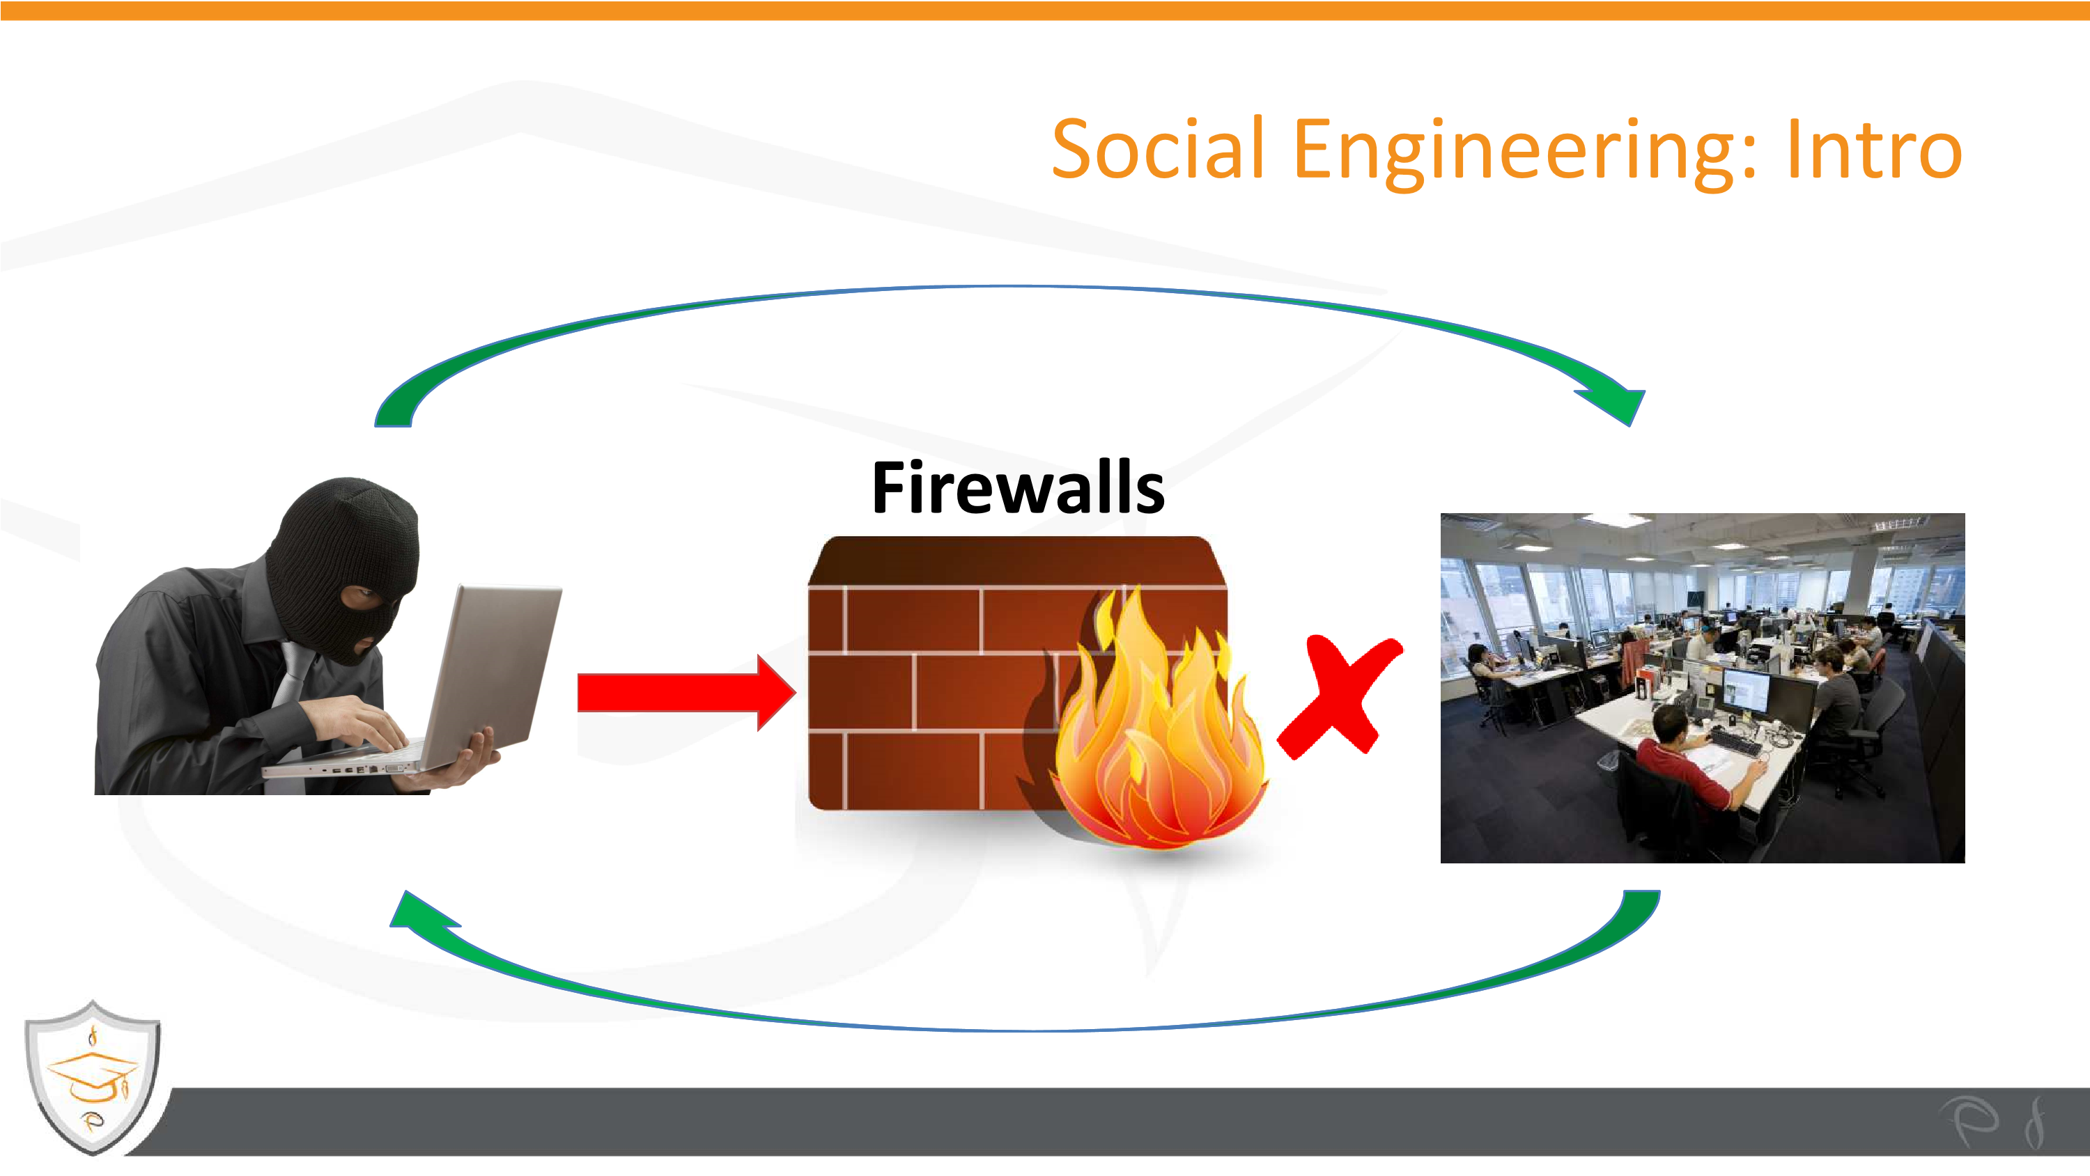



Social Engineering: Intro

•

**Victims of social engineering**

–

**RSA**

•

Infected Excel attachment, over $100 million of damage

–

**Well Fargo Bank**

•

“Catholic Healthcare” phone call, $2.1 million vanished

S hed

–

**Vodafone Help Desk**

•

Malware and fraud call, end user lost everything



Social Engineering: Intro



Social Engineering: Basics to Succeed

•

**What is social engineering?**

The attempt to control social behaviour.

–

**The 3 Critical Success Factors:**

•

trust

•

satisfaction

•

relationship



Social Engineering: Types

•

**Old-Fashioned**

Types of Social Engineering Techniques:

–

Direct approach

–

Important user

–

Helpless user

–

Technical support

–

Mail-outs

–

Social media -Facebook



Social Engineering: Types

•

1

. Direct approach

•

2

. Important user



Social Engineering: Types

•

3

. Helpless user

•

4

. Technical support



Social Engineering: Types

•

6

. Social media



•

5

. Mail-outs



Social Engineering: Types

•

**New**

**-**

**Fashioned**

Types of Social Engineering Techniques:

–

**1**

**. Phishing with new lethal-strains of ransomware**

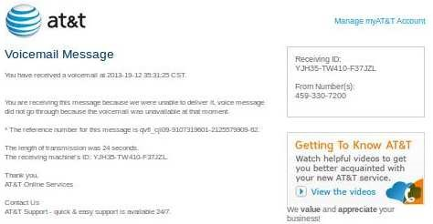

Social Engineering: Types

•

**New**

**-**

**Fashioned**

Types of Social Engineering Techniques:

–

**2**

**. IVR and robocallsfor credit card information**



Social Engineering: Types

•

**New**

**-**

**Fashioned**

Types of Social Engineering Techniques:

–

**3**

**. Phishing with funerals**

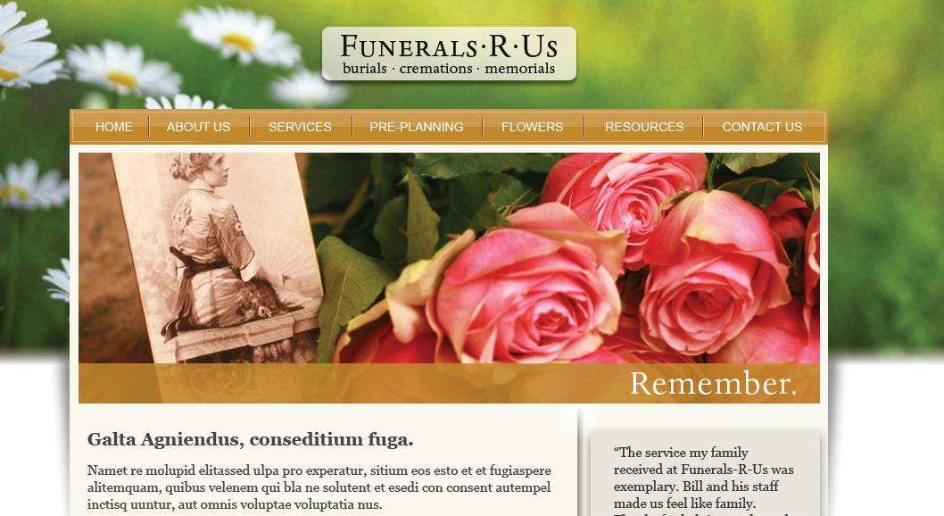

Social Engineering: Practical example

•

**1**

**st**

**step**

**:**

**Protect your identity**

–

Install new operation system on a new disk

–

Encrypt your disk

–

Use anonymous proxy

–

Use free Wi-Fi in a bar

–

Preform attack drinking cold beer

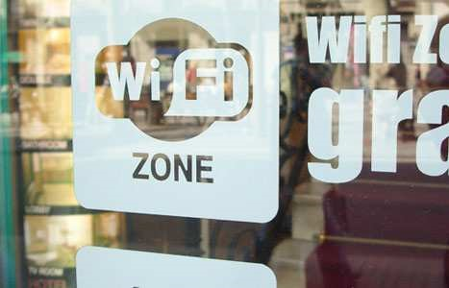

Social Engineering: Practical example

•

**2**

**nd**

**step: Fake e-mail and Facebook account**

–

The character must be:

•

Woman*

•

25

to 35 years old

•

Single

•

High educated

•

Interesting

* Statistically is proven that the success rate usi

ng a woman character

is more than 100 times (!) higher then using a male

profile.

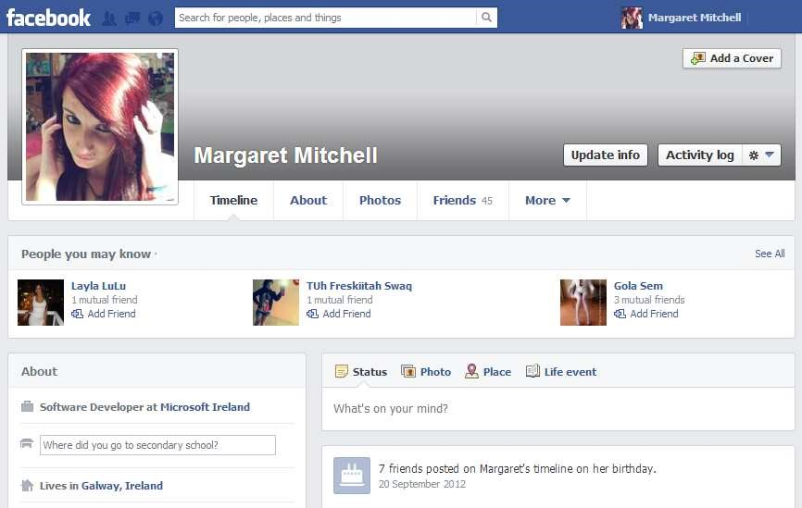

Social Engineering: Practical example

•

**3**

**rd**

**step: Select the victim(s)**

–

Before sending the invitation:

•

Get him/her friends

•

Get him/her interests

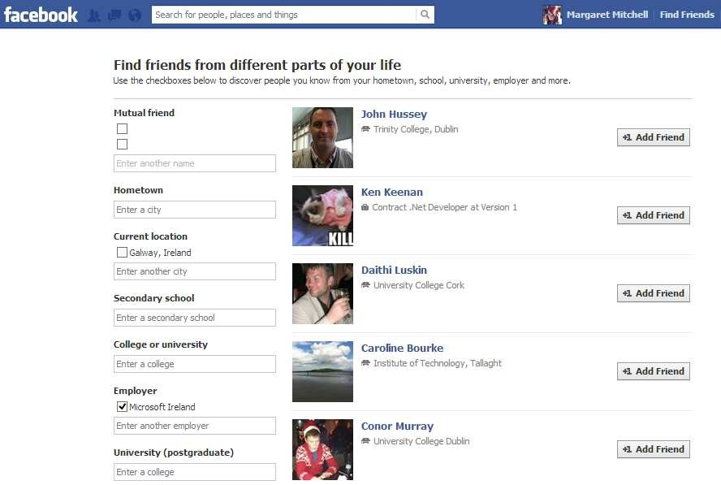

Social Engineering: Practical example

•

**4**

**th**

**step: Get the victim(s) as friend**

–

Start chatting and get sensitive information

–

Start chat and get “sensitive” photos

–

Post link to an infected site

–

…



Social Engineering: How to spot

•

**How to spot Social Engineering attack?**

–

unusual requirements

–

requiring respect for authority

–

threating with negative consequences

–

giving praise and flattery

–

offering something for nothing

–

seems too good to be true, etc…



Social Engineering: Countermeasure

• **Social Engineering Countermeasure**

# – Slow down and Research the facts

* Delete any request for financial information or passwords.



* Reject requests for help or offers of help – Don’t let a link in control of where you land – Do not post yours personal data or photos – Do not reveal sensitive data (e.g. passwords)
* **Do not avoid policies and procedures**
* Report any suspicious activity



Social Engineering: The end



**Thank you!**